# Pre-requisites

To be able to perform this tutorial you will need the following components –

1. Parts required –
   1. 1 x BBC Micro:bit
   2. 1 x Mounting Plate
   3. 1 x Edge connector breakout board
   4. 1 x Bread board
   5. 1 x LED
   6. 1 x 2.2K Ohm Resistor
   7. 2 x Male – Female Dupont wires
   8. 2 x Male – Male Dupont wires
2. Assembly required –
   1. Bread board mounted on top of the mounting plate
   2. BBC Micro:bit inserted into the Edge Connector breakout board

# C:\Perf\Personal\Github\CoderDojo\Images\Hi_Res_BBC_Microbit.jpg

Before proceeding please check your setup and confirm that all the required parts are configured as demonstrated in the above picture.

# Learning Objectives

The objectives of this tutorial are to explore and learn the basic concepts of electricity, circuits, series circuits and elements that make up a series circuit.

Explore the following concepts through making –

1. What is a circuit
2. Current flowing through a circuit
3. What are passive and active components in a circuit
4. Connecting elements in a circuit in series

# Activity

Before we get started, let’s make sure that all the required components are configured as required –

# Step 1 - Explore Fundamentals

Discuss the following concepts with the learning facilitator

1. What is a circuit
2. Current flowing through a circuit
3. What are passive and active components in a circuit
4. Connecting elements in a circuit in series

## Self-Assessment

* I can explain what a circuit means
* I can explain the differences between active and passive components in circuits.
* I have the breadboard mounted onto the mounting plate.
* I have the Micro:bit plugged into the Edge connector breakout board.

# Step 2 - Build

Let’s now connect up the relevant components on our micro:bit.

1. Connect a Male – Female Dupont wire from the 3 Volt (3V) pin on the micro:bit to the positive rail of the breadboard
2. Connect a Male – Female Dupont wire from the positive rail of the breadboard to the 2.2K Ohm resistor
3. Connect one end of the LED to the 2.2K Ohm resistor
4. Connect a Male – Female Dupoint wire to the other end of the LED and to the 0 Volt ( 0V) or ground pin on the micro:bit.

## Self-Assessment

* I understand each of the components in the circuit i.e. LED, resistor, Male – Female Dupont wires
* I have each of the elements in the circuit wired up using the breadboard
* I have checked the connections on the circuit and have not powered it on.

This now completes your circuit.

PLEASE DO NOT POWER ON YOUR MICR:BIT UNLESS YOU HAVE HAD YOUR CIRCUIT VALIDATED BY A FACILITATOR.

# Step 3 – Validate

Please call a facilitator to check your circuit before you power it on. It is important that you get a learning facilitator to check the connections on your circuit before powering it on.

Incorrect connections might result in a dead (bricked, burnt, short-circuited, etc.) Micro:bit requiring you to purchase another Micro:bit for $30 AUD.

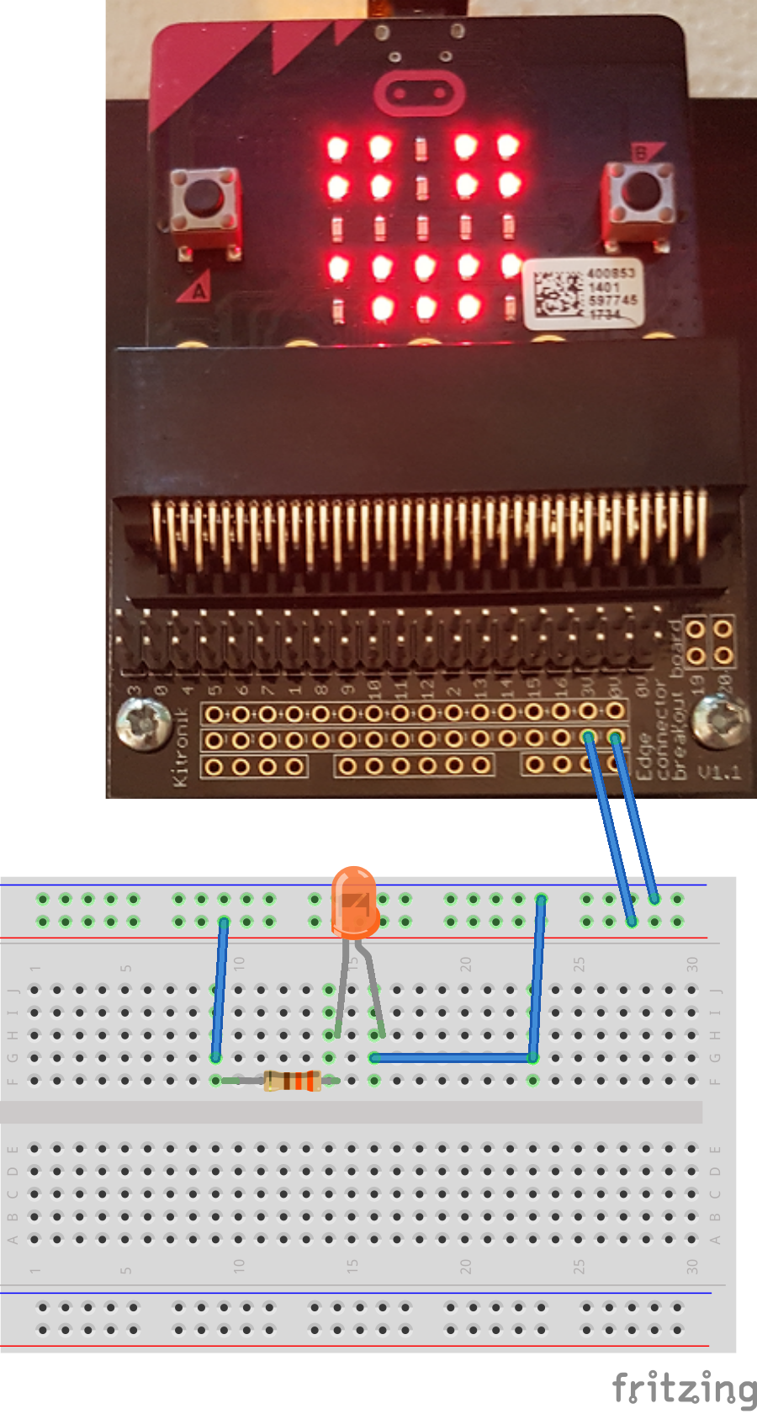

# Step 4 – Power On

Awesome, you are almost at the point where you can power on your circuit and watch the magic un-fold. Please call a facilitator to check your circuit before you power it on. It is important that you get a learning facilitator to check the connections on your circuit before powering it on.

Once the learning facilitator has verified your circuit you should now proceed and power on the Micro:bit. If you have not had your learning facilitator verify the circuit PLEASE GO BACK To step 3 and have one of the learning facilitators verify your connections.

Powering on the Micro:bit requires that you connect the USB power cord for your Micro:bit (plugged into the Micro:bit board) into your laptop.

Incorrect connections might result in a dead (bricked, burnt, short-circuited, etc.) Micro:bit requiring you to purchase another Micro:bit for $30 AUD.

## Self-Assessment

* I am able to wire a series circuit
* I understand the flow of current through a series circuit
* I understand the difference between 3 Volt (3V) and Ground (0 Volt of 0V)

# Challenges

Well done for completing the Series Circuit tutorial. There’s a lot of ground we have covered in this tutorial so please feel free to make notes, come back to the tutorial at some point down the line and ask your learning facilitator any questions or doubts you might have on the concepts covered to far.

For those who want to stretch it a bit further -

1. What happens if you add another LED or more than a couple of LED’s in series with the first one?
2. What happens if you add a lower value resistor? How is the flow of current impacted?
3. What happens if you add a higher value resistor? How is the flow of current impacted?